**Taco Junction**

The purpose of an Online Food Ordering System is to automate the existing manual system with the help of computerized equipment and full-fledged computer software, fulfilling their requirements so that their valuable data/information can be stored for a longer period with easy access and manipulation of the same. The required software and hardware are easily available and easy to work with.

Online Food Ordering System, as described above, can lead to an error-free, secure, reliable, and fast management system. It can assist the user to concentrate on their other activities rather than concentrate on record keeping. Thus it will help organizations in better utilization of resources. The organization can maintain computerized records without redundant entries. That means that one need not be distracted by information that is not relevant while being able to reach the information.

The aim is to automate its existing manual system with the help of computerized equipment and full-fledged computer software, fulfilling their requirements, so that their valuable data/information can be stored for a longer period with easy access and manipulation of the same. Basically, the project describes how to manage for good performance and better services for the clients.

The "Taco Junction" has been practiced to override the prevalent problems in manual systems. This website is compatible to finalize and, in some cases, reduces the difficulties faced by this existing system. In addition, the system is designed to function smoothly and effectively for the special needs of the company.

The website is minimized as much as possible to avoid errors when entering data. It also gives an error message when entering invalid data. No formal knowledge is required for the user to use this system. Therefore, every test is easy to use. Online food order systems, as described above, can lead to error-free, safe, reliable, and fast management systems. This can help the user focus on his other activities instead of focusing on record keeping. Therefore, it will help the organization to make better use of resources.

Website Link:- [Taco Junction](https://aditheripper.github.io/Taco-Jn/)

**SCREENSHOTS :**

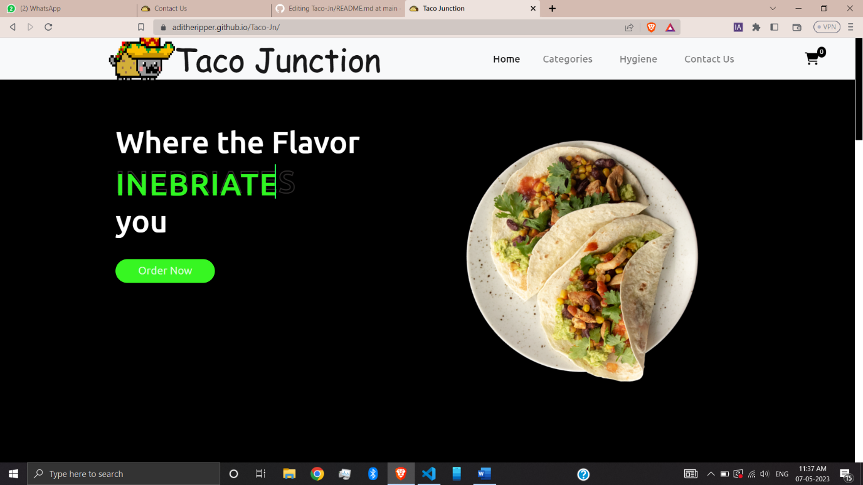

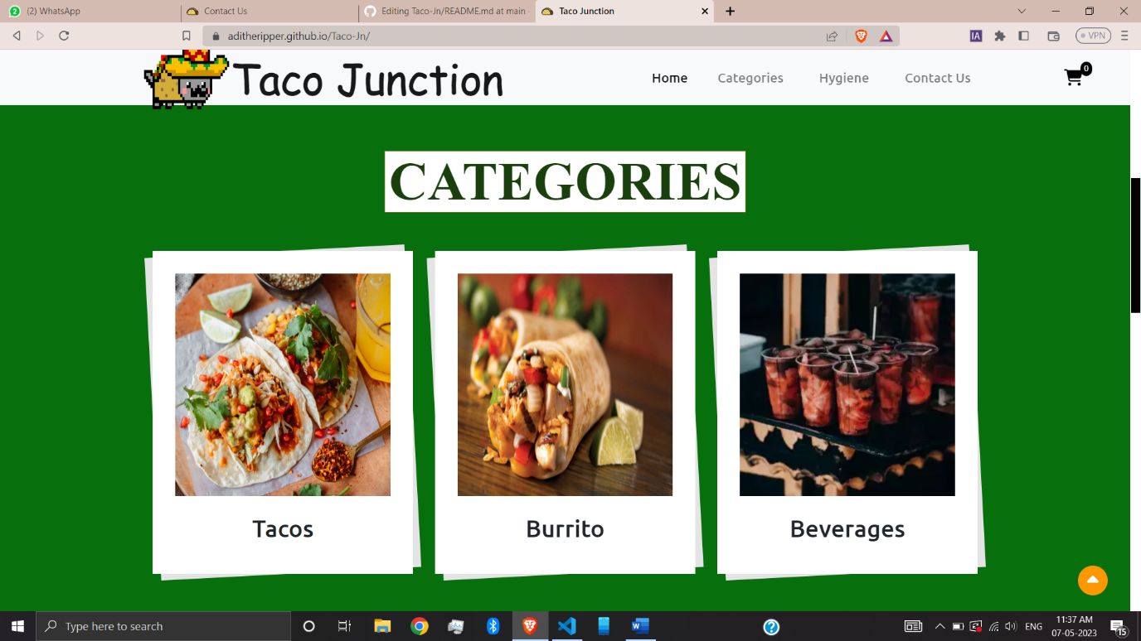

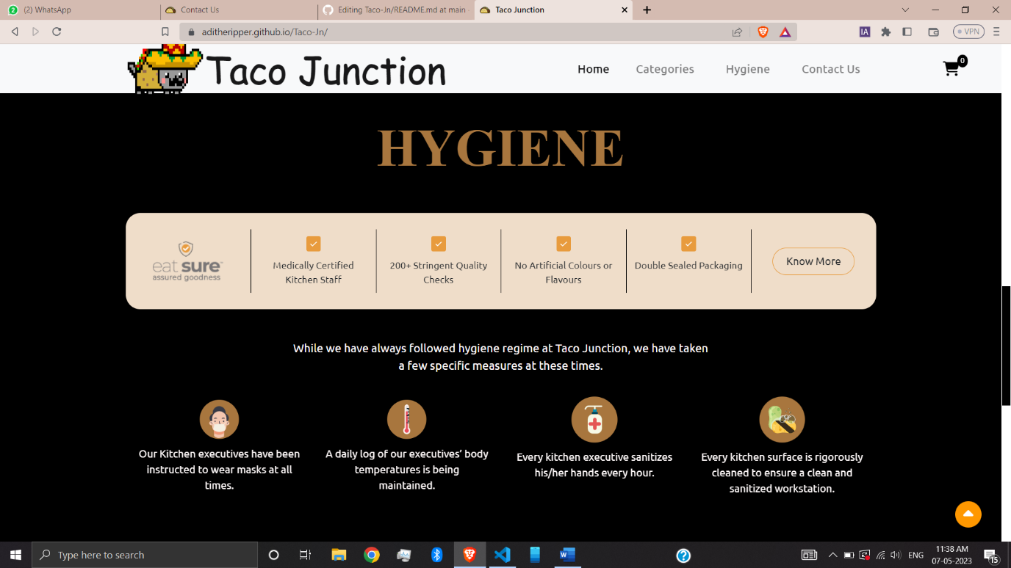

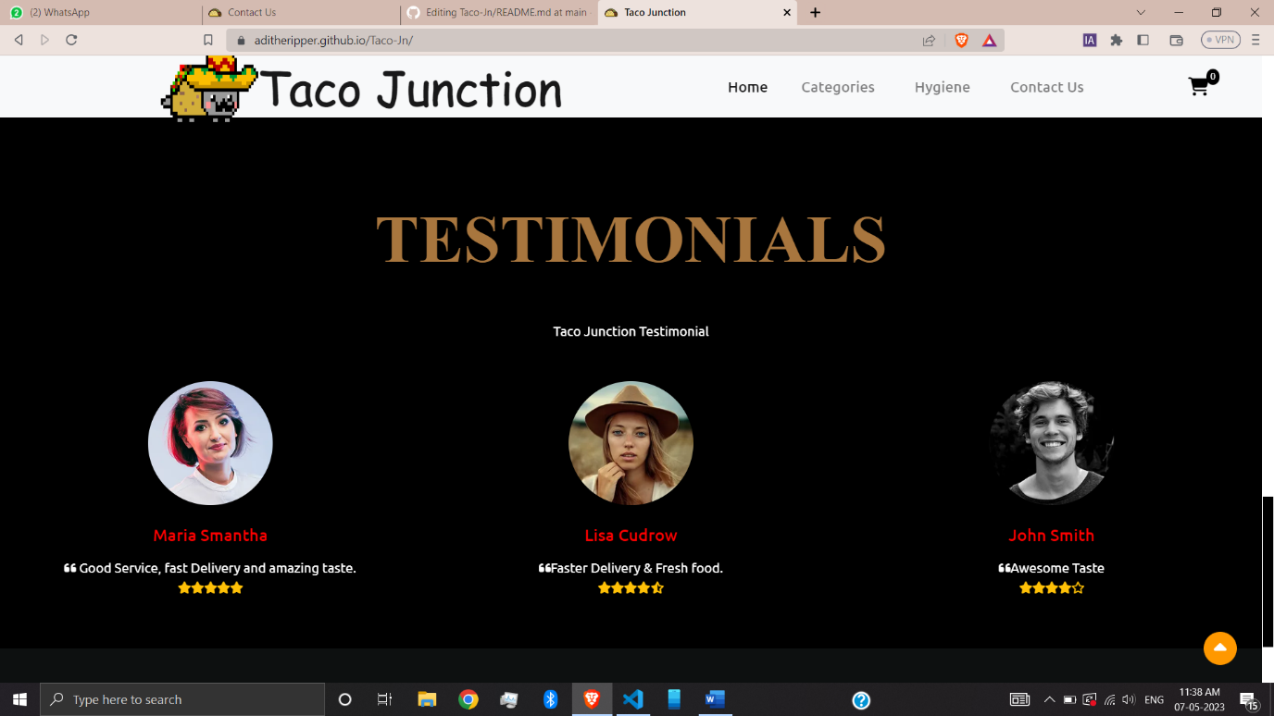

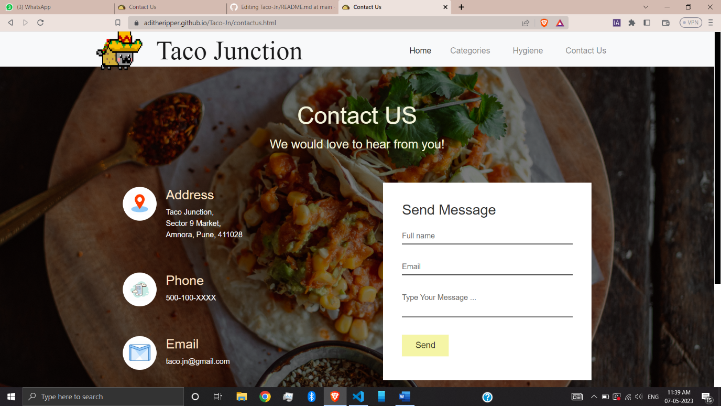

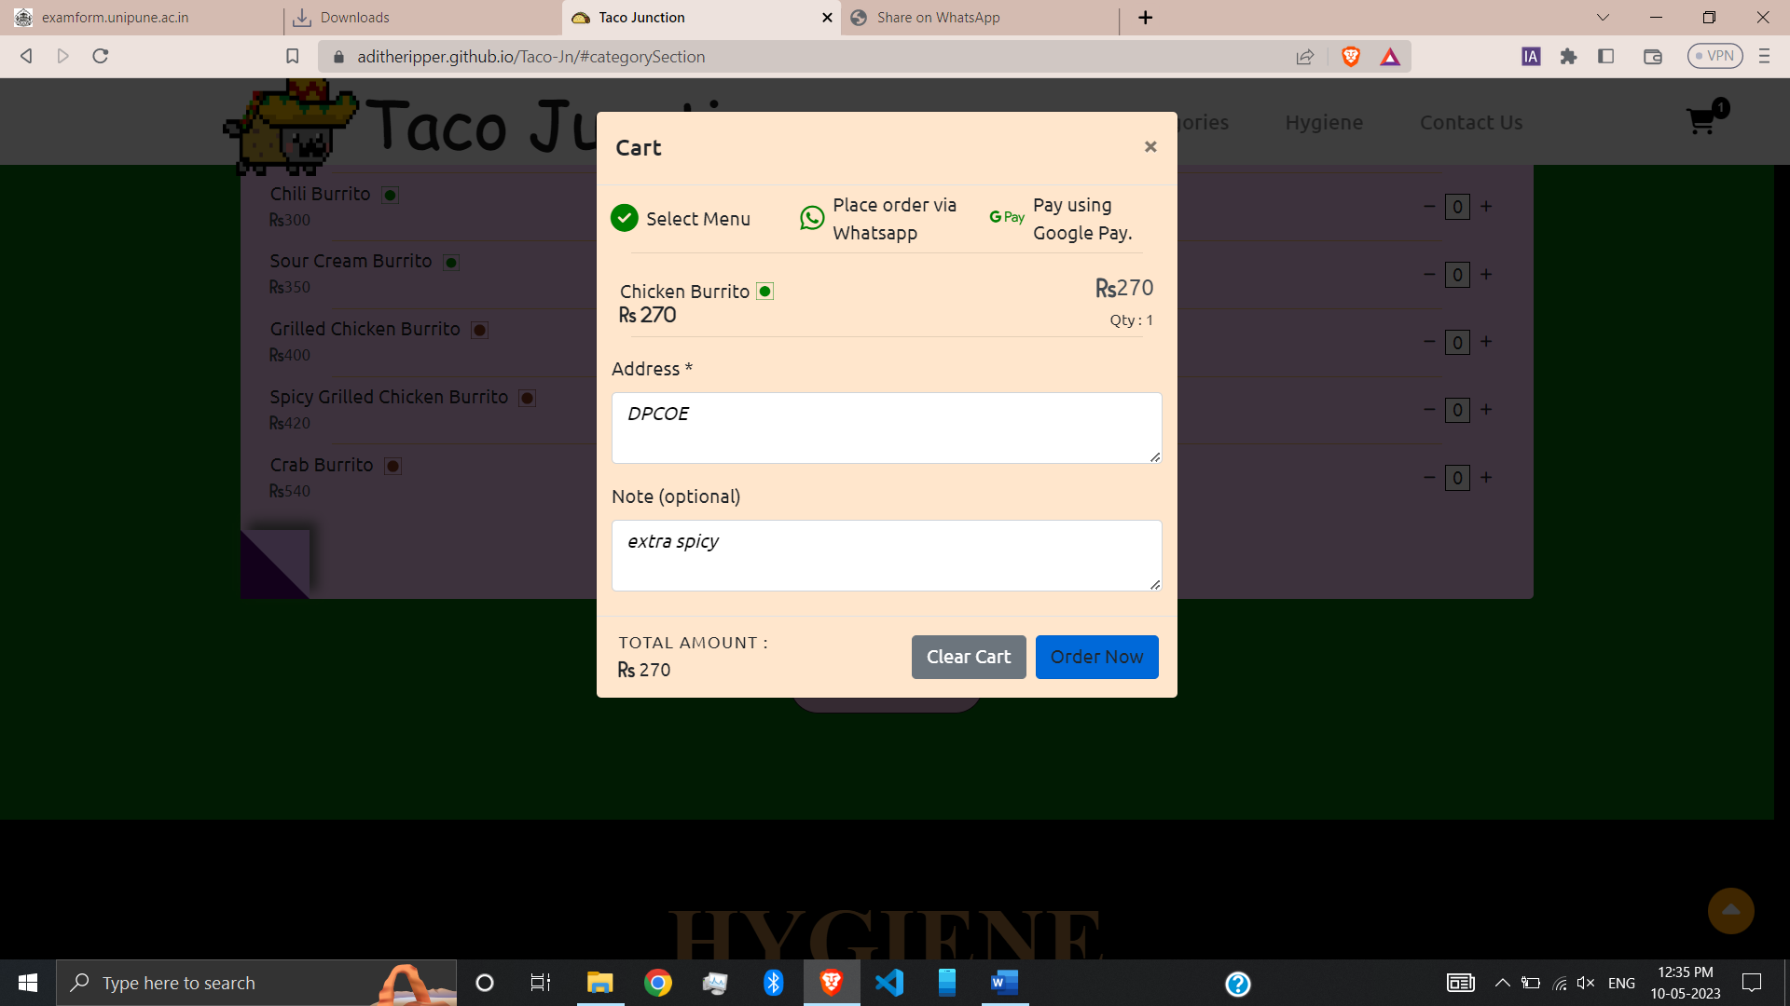

Tech Stack

* [CSS](https://www.css3.com/)
* [HTML](https://html.com/)
* [Java Script](https://developer.mozilla.org/en-US/docs/Web/JavaScript)
* [J Querry](https://jquery.com/)
* [Bootstrap](https://getbootstrap.com/)
* Whatsapp api